**DAY-1**

**DEVOPS**

**Installing and Setting Up WSL with Ubuntu on Windows 10**Before start the installation steps, check the Task Manager > Performance > CPU > **Virtualization : Enable.**

**Step 1: Enable WSL**

Before installing Ubuntu, ensure that WSL is enabled on your Windows system. **Enable WSL Feature**

1. Open **Command Prompt** as Administrator and run:

2. wsl –install

**Step 2: Install Ubuntu**

1. Open **Command Prompt** or **PowerShell** and run:

2. wsl --install -d Ubuntu

3. wsl.exe -d Ubuntu

**Step 3: Set Up Ubuntu**

When Ubuntu runs for the first time, it will ask you to create a new user account.

1. **Enter a username** (must start with a lowercase letter or underscore, and contain only  lowercase letters, digits, underscores, and dashes).

2. **Set a password** (enter and confirm the password). If passwords do not match, you  will need to retry.

3. Once successful, Ubuntu will be set up and ready to use.

**Install Jenkins on Ubuntu**

# Update package lists

sudo apt update –y

**#Install Java (Required for Jenkins)**

Sudo apt install –y openjdk-17-jdk

#**Verify Java version**

Java --version

**Add Jenkins GPG Key**

wget -q -O- https://pkg.jenkins.io/debian-stable/jenkins.io-2023.key | sudo tee /usr/share/keyrings/jenkins- keyring.asc > /dev/null

**Add the Jenkins Repository**

echo "deb [signed-by=/usr/share/keyrings/jenkins-keyring.asc] https://pkg.jenkins.io/debian-stable binary/" | sudo tee /etc/apt/sources.list.d/jenkins.list > /dev/null

**# Install Jenkins**

sudo apt update -y

sudo apt install -y jenkins

**# Start and enable** Jenkins service sudo systemctl start Jenkins

**If Jenkins not installed means do these steps as follows:  
  
# Remove the broken repository file**sudo rm -f /etc/apt/sources.list.d/jenkins.list

**# Install dependencies**

sudo apt update

sudo apt install -y apt-transport-https ca-certificates curl gnupg

**# Add the Jenkins repository key**

curl -fsSL <https://pkg.jenkins.io/debian-stable/jenkins.io-2023.key> | sudo tee /usr/share/keyrings/jenkins-keyring.asc > /dev/null

**# Add the Jenkins repository**

echo "deb [signed-by=/usr/share/keyrings/jenkins-keyring.asc] <https://pkg.jenkins.io/debian-stable> binary/" | sudo tee /etc/apt/sources.list.d/jenkins.list > /dev/null

**Step 4: Add Jenkins Repository Key**

**Step 4.1: Add Jenkins GPG Key**

wget -q -O- https://pkg.jenkins.io/debian-stable/jenkins.io-2023.key | sudo tee  /usr/share/keyrings/jenkinskeyring.asc > /dev/null

**Step 4.2: Add Jenkins Repository**

echo "deb [signed-by=/usr/share/keyrings/jenkins-keyring.asc] https://pkg.jenkins.io/debian stable binary/" |

sudo tee /etc/apt/sources.list.d/jenkins.list > /dev/null

**Step 5: Install Jenkins**

sudo apt update -y

sudo apt install -y jenkins

**Step 6: Start and Enable Jenkins Service**

sudo systemctl start jenkins

sudo systemctl enable jenkins

**Step 7: Check Jenkins Status**

sudo systemctl status jenkins

cat copy the localhost:8080 admin path

display the password

sudo cat <Path specified in the Jenkins page>

## =>By default, Jenkins runs as a system user (jenkins). If your script requires sudo, you must allow the Jenkins user to run commands without a password.

sudo visudo

## Add the following line at the end:

jenkins ALL=(ALL) NOPASSWD: ALL

Save and exit.

Sudo systemctl start jenkins  
Sudo systemctl enable jenkins  
Sudo systemctl status jenkins

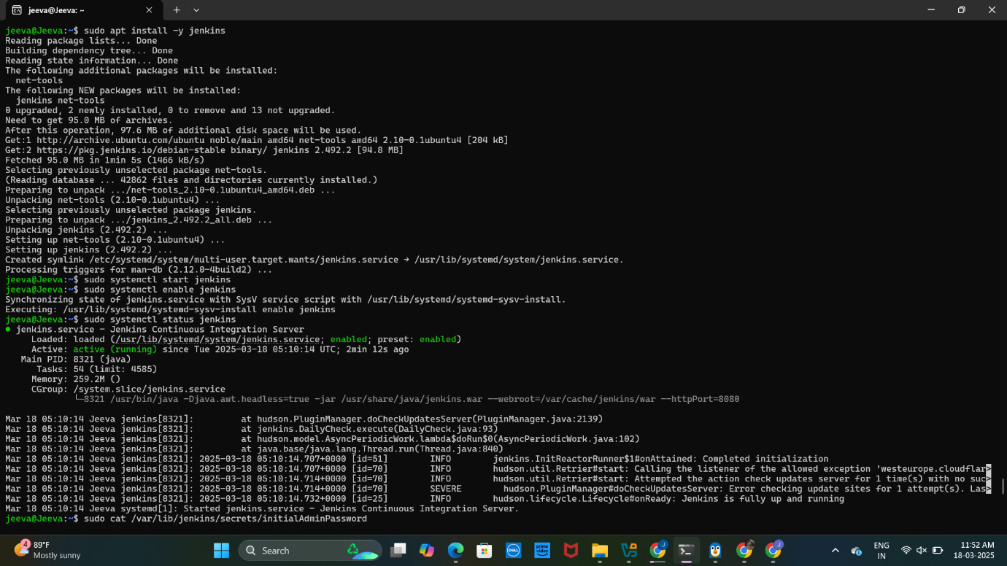

**2. Access Jenkins Web Interface**

Jenkins will be available at http://localhost:8080

**To Get the Jenkins Server URL, Follow These Steps:**

**Method 1: Check the Default URL**

By default, Jenkins runs on port 8080. Open in a browser:

http://<your-server-ip>:8080

If you're on the same machine as Jenkins, use:

http://localhost:8080

**Choose Install suggested plugins**

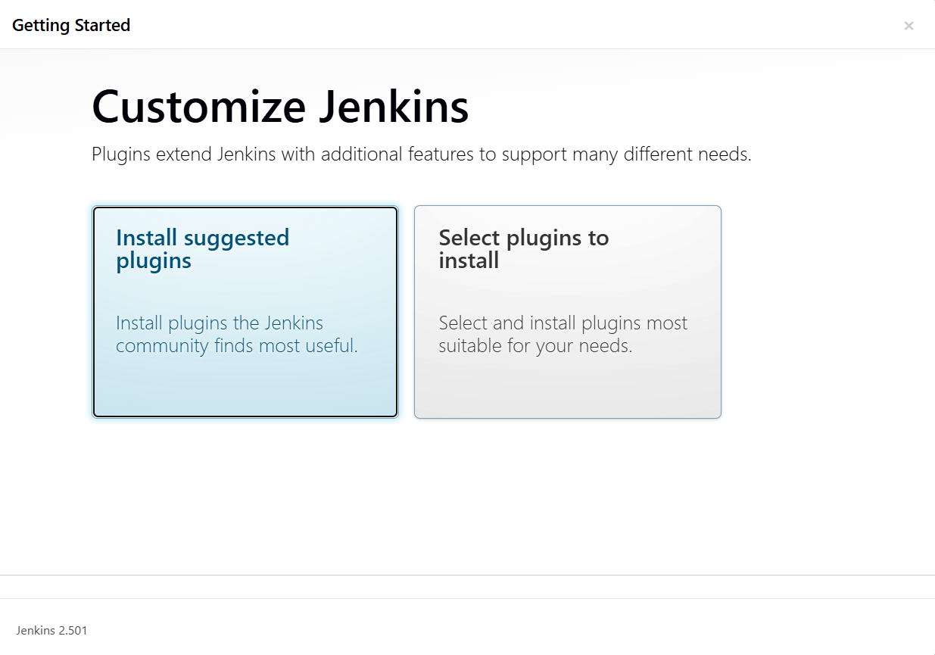

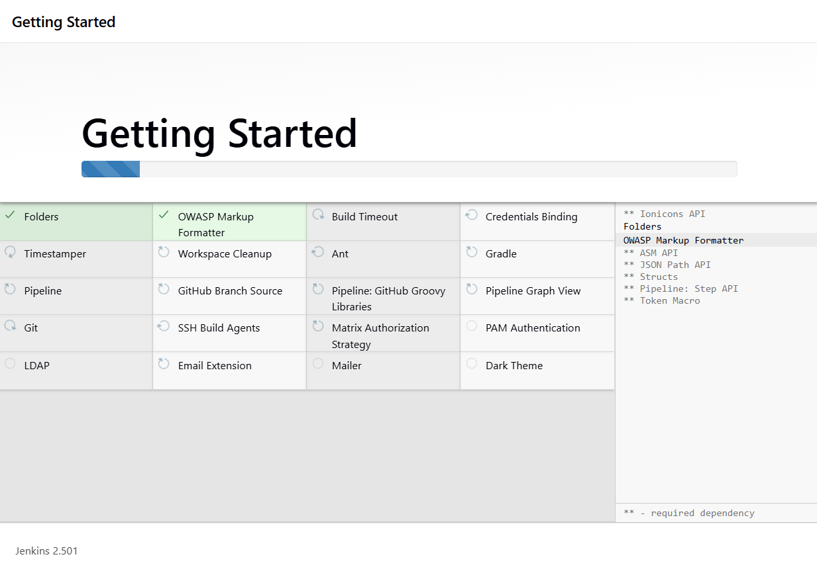

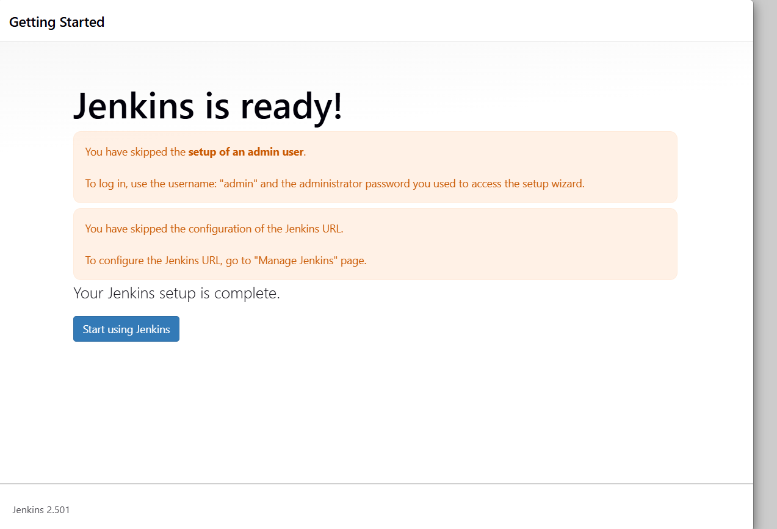

**Step-by-Step Guide to Creating a Freestyle Job in Jenkins to Install Nginx Step 1: Create a New Freestyle Job**

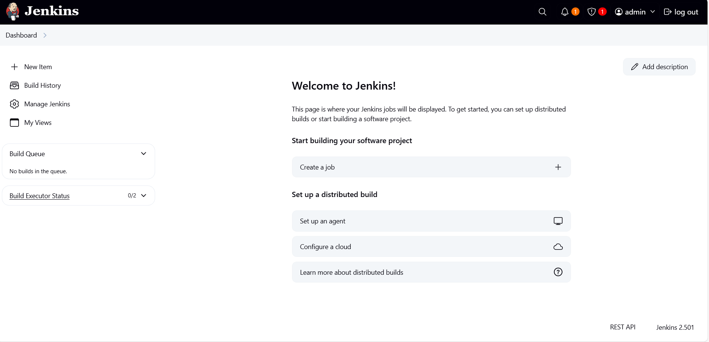

1. Click on **New Item** from the Jenkins Dashboard.

2. Enter a name for the job, e.g., *Install-Nginx*, demo, test

3. Select **Freestyle project**.

4. Click **OK**.

**Step 2: Configure the Job**

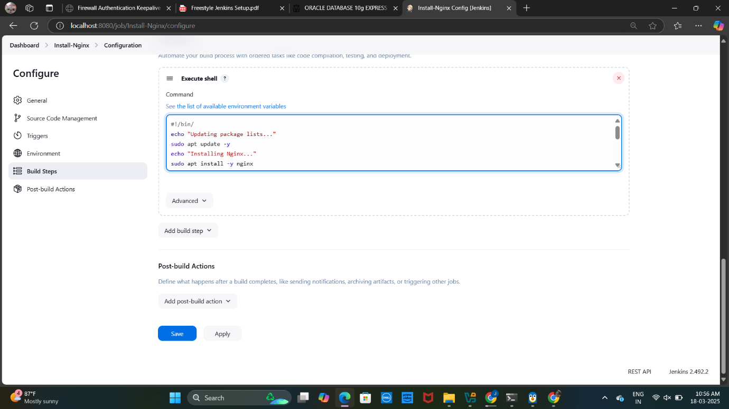

**Add Build Step**

1. Scroll down to **Build** → Click *Add build step* → Select **Execute shell**.

2. Paste the following script in the command box:

echo "Updating package lists..."

sudo apt update -y

echo "Installing Nginx..."

sudo apt install -y nginx

echo "Starting Nginx service..."

sudo systemctl start nginx

echo "Enabling Nginx to start on boot..."

sudo systemctl enable nginx

echo "Nginx Installation Completed!"

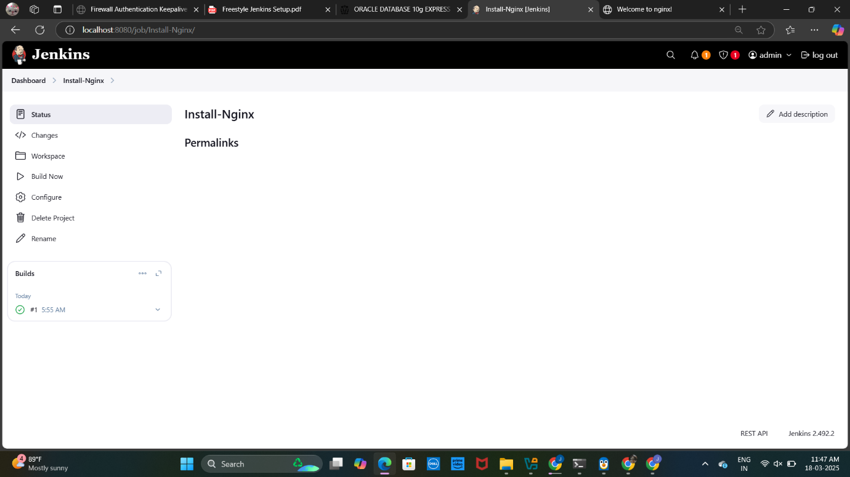

**Step 3: Save and Run the Job**

1. Click **Save**.

2. Click **Build Now**.

3. Check the **Console Output** to verify the installation.

**Step 4: Verify the Installation**

**1. Check Nginx Status**

systemctl status nginx

If running, you should see output like *"active (running)"*.

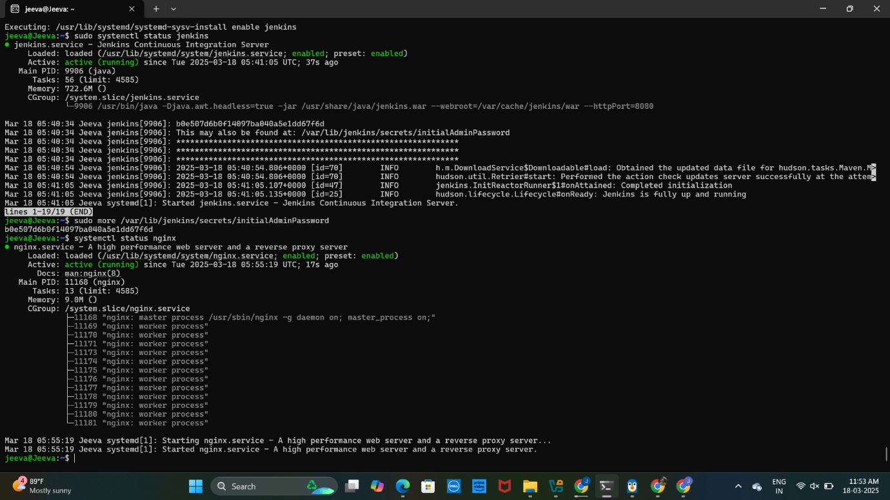

**2. Open Nginx in Browser**

http://localhost:80

You should see the default Nginx welcome page

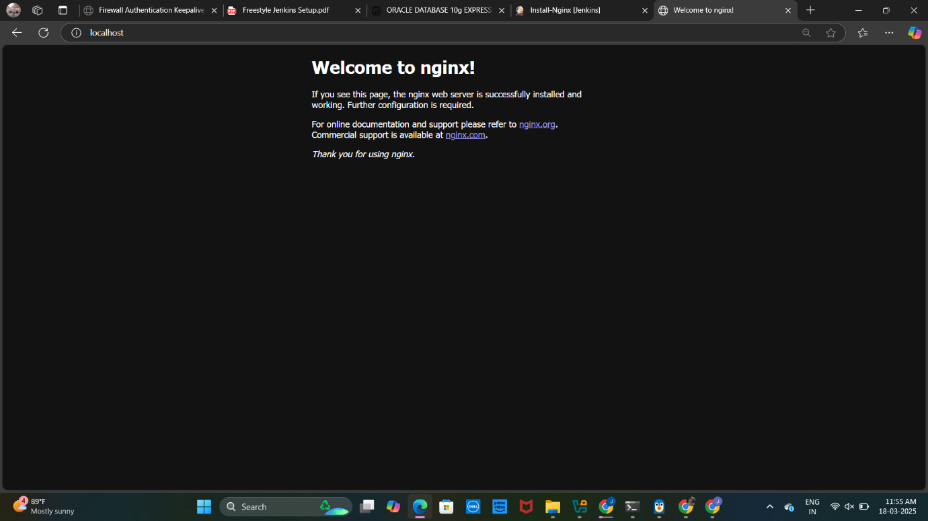

--- Day 1 task is completed ---